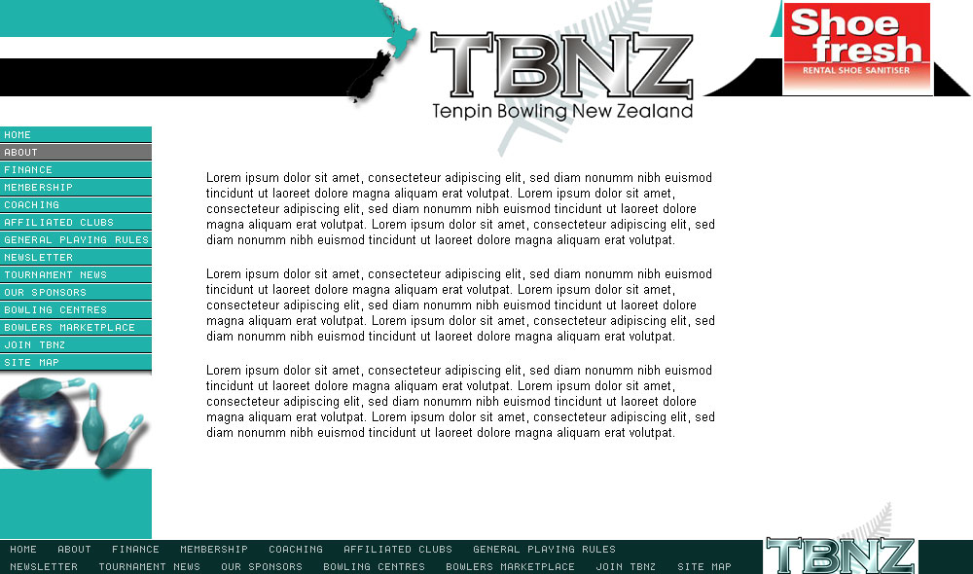

Tenpin Bowling New Zealand Inc
266 Sturges Road
Henderson
AUCKLAND 0612

+64 223123529

info@tbnz.co.nz
www.tbnz.co.nz

2016 NOMINATION FORM

FOR

DIRECTOR OF TBNZ

Nominee ___________________________

Signed ___________________________

Position ___________________________

Nominator ___________________________

Signed ___________________________

Nominator ___________________________

Signed ___________________________

Date _______________________

