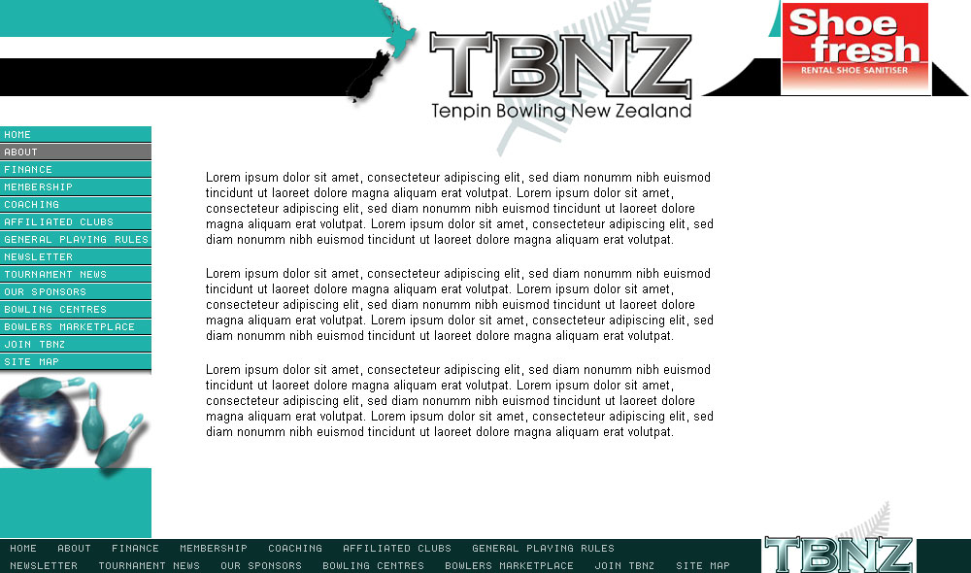

Tenpin Bowling New Zealand Inc
266 Sturges Road
Henderson
AUCKLAND 0612

+64 223123529

info@tbnz.co.nz
www.tbnz.co.nz

Tenpin Bowling New Zealand Inc
P O Box 79013
Royal Heights
AUCKLAND

+64 223123529

Notice of Motion 2016

(start here)

________________________________________________________________________________

Moved ___________________________

Signed ___________________________

Seconded ___________________________

Signed ___________________________

Date ___________________________

